**UI/UX Home Assignment:**

**NutriTrack Figma UI**

Of

**“NutriTrack: Nutrition & Diet Planner System”**



SUBMITTED

TO

**VISHWAKARMA INSTITUTE OF INFORMATION TECHNOLOGY, PUNE**

IN

**DEPARTMENT OF ELECTRONICS AND TELECOMMUNICATION**

**AY 2024-25**

**Semester III**

BY

|  |  |  |  |  |
| --- | --- | --- | --- | --- |
| **Name** | **PRN** | **Roll Number** | **Mobile Number** | **Email ID** |
| Atharva Santosh Suryavanshi | 22310487 | 211030 | 7840972377 | atharva.22310487@viit.ac.in |
| Atharva Vinayak Maslekar | 22310981 | 211037 | 7719097941 | atharva.22310981@viit.ac.in |
| Atharva Rajendra Joshi | 22311496 | 211049 | 9527043551 | atharva.22311496@viit.ac.in |
| Manas Girish Kulkarni | 22311360 | 211058 | 7972470825 | manas.22311360@viit.ac.in |

**Class: S. Y. B. Tech**

**Division: A**

**Faculty In-Charge / Evaluator**

**Mrs. Riddhi Mirajkar**

**User Interface**

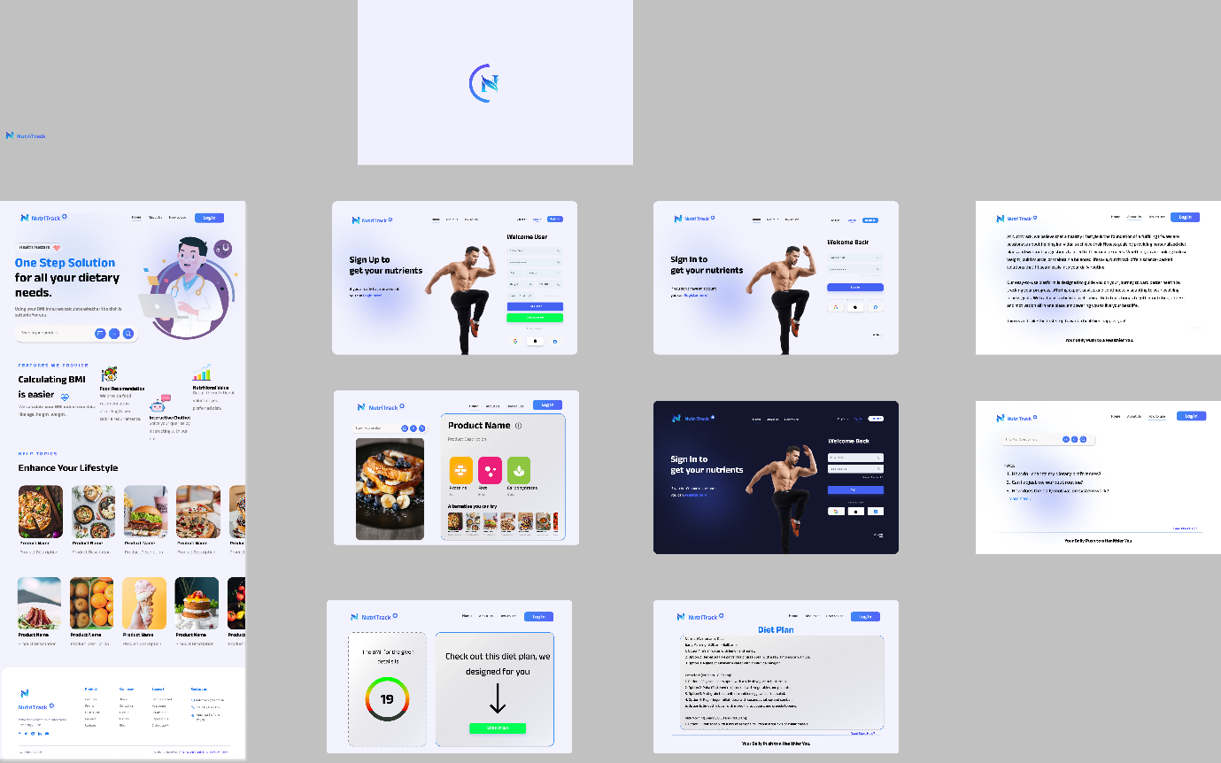

**Wireframe**

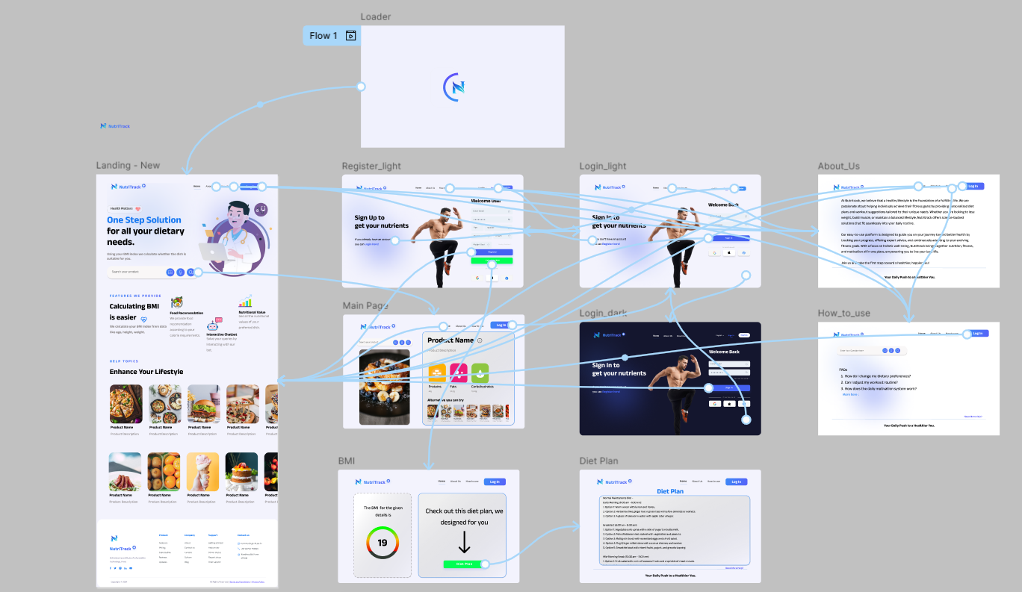

**Figma Project (UI) Link:** <https://www.figma.com/design/nu0x2CaCSXqjagfStO3UV9/NutriTrack?node-id=0-1&t=4pJjVj6lT3SnkLyi-1>

**Figma Prototype Link:** <https://www.figma.com/proto/nu0x2CaCSXqjagfStO3UV9/NutriTrack?node-id=0-1&t=4pJjVj6lT3SnkLyi-1>

**Design Decisions**

**1. Branding and Identity**

* **Logo**: The NutriTrack logo is placed consistently across all pages, reinforcing brand identity. It combines a modern, sleek look with minimalism, providing a strong, recognizable symbol.
* **Color Scheme**: The design uses a cool-toned color palette, primarily blues and whites, which creates a calming effect. Blue conveys trust and reliability, perfect for a health and nutrition platform.

**2. Homepage (Main Landing Page)**

* **Structure**: The homepage is well-structured, offering an overview of the platform's features like BMI calculation, food recommendations, and nutritional value tracking. Key sections include:
  + **Main Banner**: Eye-catching with a medical professional illustration, emphasizing NutriTrack’s role as a health-oriented tool.
  + **Features Section**: Prominent icons highlight features like BMI calculation and interactive charts, making the information digestible and easy to access.
  + **Help Topics**: The section on enhancing lifestyle presents visually appealing product recommendations.
* **Call-to-Action (CTA)**: The 'Sign Up' and 'Login' buttons are strategically placed at the top right, driving user engagement.

**3. Onboarding and User Login/Signup**

* **Simple Registration**: The UI includes separate login and signup pages with a clean, minimalistic layout. These pages focus on user onboarding with input fields for credentials and CTA buttons like "Sign Up" and "Log In."
* **Visual Focus**: Images of a fitness model on these pages highlight NutriTrack’s focus on health and fitness, adding visual motivation for users.

**4. Product and Nutritional Information**

* **Product Details Page**: There’s a dedicated section for displaying food product information, including visuals, product names, and nutritional content (carbohydrates, proteins, fats). It uses a card-style layout to make the products stand out.
* **Categorization**: The products are neatly categorized with clear labeling, making it intuitive for users to browse through various food items.

**5. BMI Calculator**

* **Interactive BMI Calculation**: A dedicated section allows users to input their details to calculate BMI. The results are prominently displayed in a clean, easy-to-read format.
* **Diet Plan Recommendation**: The UI automatically suggests a diet plan based on the user’s BMI. This feature enhances personalization by offering tailored diet advice, further encouraging user engagement.

**6. User Dashboard**

* **Welcome Back Screen**: The dashboard welcomes returning users with motivational visuals (e.g., the fitness model), focusing on diet tracking and nutrient management. It is designed to display daily nutrient intake in a simple, concise manner.
* **Interactive Data**: It integrates graphs or trackers for users to monitor their progress, making the experience more interactive.

**7. Diet Plan Page**

* **Diet Plan Layout**: The UI also features a page specifically for diet plans, offering personalized recommendations based on user inputs. The plan is easy to navigate, presented as a step-by-step list of daily meals, ensuring clarity for users.

**8. Help and FAQ**

* **FAQ Section**: The UI offers a dedicated Help/FAQ section to answer common questions like dietary preference changes, nutrient recommendations, and system functionality. The page has a clear and simple layout, focusing on usability.
* **Support**: The inclusion of FAQs and support links improves user confidence, making the platform accessible for users unfamiliar with nutritional systems.

**9. Dark Mode**

* **Design Consistency**: NutriTrack also features a dark-themed interface, visible in the user login and dashboard screens. This theme is a thoughtful addition for users who prefer dark mode for better visual comfort, especially for late-night usage.
* **Contrast**: The dark mode maintains high contrast between text and background, ensuring readability and an engaging experience without overwhelming the user.

**10. Visual Appeal and Graphics**

* **Illustrations**: The illustrations, such as those on the homepage and other sections, bring a friendly and approachable feel to the design, making it more engaging.
* **Photography**: High-quality images of healthy foods and the fitness model across multiple screens contribute to a sense of motivation and align with the app’s health-conscious brand.

**11. User Experience (UX) and Usability**

* **Intuitive Navigation**: The navigation menus are clear and concise, making it easy for users to move between different sections, such as BMI calculators, diet plans, and product information.
* **Responsive Layout**: The design appears to be structured for responsiveness across devices, offering a consistent experience for desktop and mobile users.

**12. Conclusion**

* The NutriTrack UI design successfully balances aesthetics with functionality, creating an engaging and user-friendly experience. The clean and intuitive layouts make navigating health-related features like BMI calculation and diet tracking simple and approachable for users. The incorporation of motivational imagery, easy registration, dark mode options, and personalized nutritional insights shows a thoughtful approach to enhancing the user experience.